# Comparing Numerical & Analytical Models of the Radioactive Decay of Two Different Nuclei

##### **Dylan Hilligoss1**

1 Department of Physics and Astronomy, University of Delaware

**Abstract**

In this report, applications of the Euler method are examined in solving for the quantities of two different radioactive elements as a function of time. To test the validity of these numerical simulations, analytical solutions are also provided for comparison. These comparisons were made by conducting three cases in which the value of Element B’s time constant $τ_{B}$ was changed to be greater than, equal to, and less than the value of $τ_{A}$. Results indicate that for all three cases (with a proper timestep), the numerical models solved using Euler’s method line up almost exactly with the predicted analytical solutions to the ODEs that describe the behavior of this decay.

PACs: 23.90.+w

1. **Introduction**

Heavy elements found on the periodic table undergo the process of radioactive decay. This is the procedure in which an unstable atomic nucleus loses energy by radiation. Most elements on the periodic table containing more atomic mass than lead (*Pb*) undergo this process of decaying into a stable element. This decay process can be described both physically and quantitatively. Radioactive decay can mathematically be described by an ordinary, first order, differential equation (ODE) to find the number of nuclei of a given element over some period of time.

As the “age of numerical analysis” grows in popularity, it is important to test the validity of these results by comparing them to exact results which can be found analytically. Using numerical techniques such as the Euler Method and the Monte Carlo Method usually provide excellent approximations when solving problems with large amounts of data.

Many situations make use of numerical analysis. For this report, the situation in which the nuclei from element A decay into nuclei from some different element B is considered. This radioactive decay from element A to B can be described through the system of coupled ODEs:

$$\frac{{dN}_{A}}{dt}=-\frac{N_{A}}{τ_{A}} (1)$$

$$\frac{{dN}_{B}}{dt}=\frac{N_{A}}{τ_{A}}-\frac{N_{B}}{τ_{B}} \left(2\right)$$

where $τ_{A}$ and $τ_{B}$ are the decay time constants associated with each element. The initial conditions to this specific problem include setting $N_{A}\left(0\right)=500$, $N_{B}\left(0\right)=5$, and $τ_{A}=1$.

The ultimate goal of this problem is to solve the coupled equations (1) and (2) for $N_{A}\left(t\right)$ and $N_{B}\left(t\right)$ both numerically and analytically; then compare the results.

1. **Methodology**

To begin, consider how to solve this problem not only analytically, but also numerically.

*2.1.* **The Euler Algorithm**

The Euler Method or Algorithm was developed by Leonhard Euler as a device to numerically solve ODEs with a given initial value.

To help better understand the significance of the Euler method, consider the problem of calculating the shape of an unknown curve which starts at some given point and satisfies a given differential equation (in this case, a set of differential equations). Here, the differential equations can be thought of as formulae by which the slope of the tangent line to the curve can be computed at any point along that curve, once the position of that point has been calculated. The idea is that while the curve is initially unknown, its starting point, which is denoted as $N_{0}$ is known. Then, from the differential equation, the slope to the curve at  {\displaystyle A_{0}}can be computed, and so, the tangent line.

The simplest way to obtain the Euler algorithms for elements A and B in this problem would be through an approximation of the ODEs’ mathematical Taylor expansion for the number of nuclei at some time $N(t+∆t)$. This expansion can be described by:

$N\left(t+∆t\right)≈N\left(t\right)+\frac{dN}{dt^{'}}∆t+O{\left(∆t\right)}^{2} (3)$

Right away, one can see that quality of (3) is heavily dependent on the selected value of $∆t$. To continue, the next step is to now normalize the

approximated Taylor expansions.

*2.1.1* Nondimensionalization &

Normalization

To avoid using up too much memory, it is often easier to convert the equations into dimensionless form and normalize. In this specific case, this procedure will be done on element A and B. Since (1) and (2) are coupled together, the normalized version will be dependent on one another. In the case of equation (1), by defining a timescale $t_{0}$, the physical time can be measured by defining a dimensionless time variable where:

$$\overline{t}=\frac{t}{t_{0}} (4)$$

By the chain rule and the addition of $t_{0}$, equation (1) can be rewritten as:

$$\frac{1}{t_{0}}\frac{dN_{A}}{d\overline{t}}=-\frac{N_{A}}{τ_{A}} (5)$$

From this, a new dimensionless time constant $\overline{τ}$ can be determined.

$$\overline{τ}=\frac{τ}{t_{0}} (6)$$

Then, by setting $\overline{τ}=1$ suggesting that $t_{0}=τ$, the nondimensionalized, normalized form of equation (1) can be written as:

$$\frac{dN_{A}}{d\overline{t}}=-N_{A} (7)$$

Thus, the Euler algorithm for element A can be described as:

$$N_{A}\left(t+∆t\right)=N_{A}\left(t\right)-{(N}_{A}\left(t\right)*dt) (8)$$

where $dt$ is a preselected timestep interval value.

A similar process of nondimensionalization can be conducted to obtain the normalized version of equation (2) describing element B. By invoking the definition of a differential limit, one can obtain the following expression:

$$\frac{dN_{B}}{dt}=\frac{{N_{B}\left(t+∆t\right)-N}_{B}\left(t\right)}{∆t} (9)$$

Also, by relating $\frac{dN_{B}}{dt}$ and $\frac{dN_{A}}{dt}$ shown in equation (9), one can see that

$$\frac{dN_{B}}{dt}=N_{A}-\frac{N_{B}τ_{A}}{τ_{B}} (10)$$

Equating the two $\frac{dN_{B}}{dt}$ terms yields the normalized Euler algorithm for equation (2).

$$N_{B}\left(t+∆t\right)=N_{B}\left(t\right)+\left(N_{A}-\frac{N_{B}τ_{A}}{τ_{B}}\right)dt (11)$$

*2.2* **Analytical solutions**

Now that the ODEs identified in equations (1) and (2) have been solved numerically, solving them analytically to find the exact solutions will provide a great comparison to test the validity of the Euler algorithms and numerical method of solving for this case.

Using the symbolic mathematical computation program Mathematica, exact, or analytical, solutions to equations (1) and (2) were obtained trivially through simple integration. The exact solution to equation (1) was found to be:

$$N_{A}\left(t\right)=200e^{-t} (12)$$

The exact solution to (2) is more intricate, as shown by the following Mathematica solution:

$$N_{B}\left(t\right)=-\frac{5e^{-t-\left(\frac{t}{τ_{B}}\right)}}{\left(-1+τ_{B}\right)}\left(e^{t}-41τ_{B}e^{t}+40{τ_{B}e}^{\frac{t}{τ_{B}}}\right) (13)$$

In the next sections, a comparison between the numerical and analytical solutions will be made for three separate cases relating values of $τ_{B}$ to $τ_{A}$.

1. **Numerical & Analytical results**

Now that solutions for these ODEs have been found both numerically and analytically, a comparison between the numerical and exact solutions can be made for the number of atomic nuclei of element A and element B. To highlight the contrasts between the results when altering the value of the time decay constant for element B ($τ_{B}$), three cases are presented below.

*3.1* **Comparing Time Constant Values**

It is important to study the effect that the time constant $τ$ has on the decay rate of the two nuclei in question. The time constant is a value that represents the mean lifetime of a decaying atomic nucleus. The goal in this problem is to compare $N_{A}\left(t\right)$ to $N_{B}\left(t\right)$, or the number of nuclei of element A to B over time. Intuitively, it can be deduced that $τ$ is proportional to $N\left(t\right)$. Below the three cases are presented.

*3.1.1 $τ_{A}>τ_{B}$* case

This first case examines when time constant $τ_{A}$ is greater than $τ_{B}$. In this case, element A, which decays into element B, takes slightly longer to decay which leads to a smaller $N_{B}\left(t\right)$ value. Figure 1 shows the results of the numerical simulation.

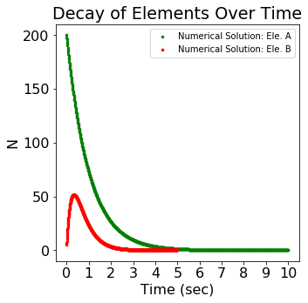

Figure 1: In the case where $τ_{A}>τ_{B}$ where $τ_{A}=1.0$ and $τ_{B}=0.5$, following the Euler method produces a numerical result in which the number of element A nuclei decreases at a rate which only allows for a small peak in the number of element B nuclei.

Following the Euler Method leads to results that physically make sense. As $N_{A}\left(t\right)$ decreases over time, naturally, $N_{B}\left(t\right)$ should increase a certain amount since element A decays into element B. But since element A has a larger time constant, the half-life of each nuclei is longer. This leads to a depressed production of element B nuclei since element A is decaying slower. The trend of the $N_{B}\left(t\right)$ line follows an upward trend to a distinct peak, or maximum value, then begins to decrease back towards zero. This decrease occurs due to the larger value of the time constant ratio where

$$τ_{R}=\frac{τ_{A}}{τ_{B }} (14)$$

In this case, $τ_{R}=2.0$. With a larger time constant ratio, element B takes longer to be produced, which leads to a smaller number of total element B nuclei.

*3.1.2 $τ_{A}<τ_{B}$* case

In the next case, the values of the time constants are reversed. Now, element B has a larger time constant than that of element A. Considering the argument from the previous section one could reasonably expect that element B will now produce a higher $N_{B}\left(t\right)$ value before beginning to decrease. Indeed, Figure 2 shows this.

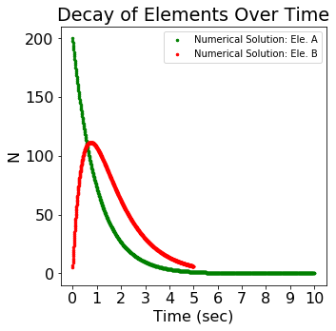

Figure 2: In the case where $τ_{A}<τ_{B}$ where $τ_{A}=1.0$ and $τ_{B}=2.0$, element B has a substantially higher peak due to the smaller time constant ratio. With a smaller time constant ratio, it takes less time for element A to decay therefore allowing for increased production of element B.

The numerical solutions emphasized in this case yield a result in which the peak of the $N_{B}\left(t\right)$ line is now approximately double the height from the height shown in section *3.1.1*. With a smaller time constant ratio ($τ_{R}=0.5$), more element B nuclei can be produced over a longer period of time before $N_{B}\left(t\right)$ starts to decrease.

*3.1.3 $τ_{A}=τ_{B}$* case

The third and final case in this report is when the time constants for element A and B are equal. Now, $τ_{A}=τ_{B}=1.0$. Figure 3 shows the relationship between the number of nuclei of element A and B when the time constants are equal.

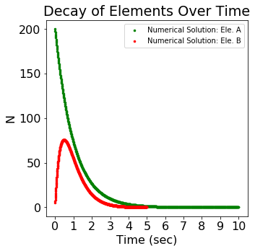

Figure 3: In the case where $τ_{A}=τ_{B}=1.0$, notice that element B produces a peak number of nuclei that is approximately half way between the peaks presented in sections 3.1.1 and 3.1.2. In addition, having a time constant ratio equal to 1 suggests that both elements should decay at the same rate.

When the time constants are equal, or equation (14) equals 1.0, the rate of decay for both elements should be equal. Figure 3 shows an almost identical decay rate between elements A and B, backing up this theory. In this special case, the numerical solutions help to determine the nature of these ODEs at a value in which the exact solution breaks down.

*3.2* **Comparing The Numerical &**

**Analytical Solutions**

To test the validity of the numerical results provided in the previous sections, a comparison to the exact analytical solutions should be made. Luckily, in this problem, such a comparison can easily be made.

Revisiting the case where $τ_{A}>τ_{B}$, Figure 4 shows the comparison between the numerical and analytical solutions of both elements.

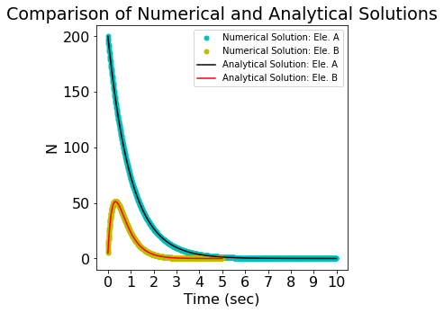

Figure 4: Here a comparison between the numerical and analytical solutions of both elements are made in the case presented in section 3.1.1. The lack of discrepancy between the numerical and exact solutions suggest that the Euler algorithm is a good approximation in this case.

As is clearly shown in Figure 4, there is minimal discrepancy between the numerical and exact solutions for both element A and B. This shows that the Euler method for this case works.

Figures 5 and 6 show the comparisons between the numerical and exact solutions for the other two cases where $τ_{A}<τ_{B}$ and $τ_{A}=τ_{B}$ respectively.

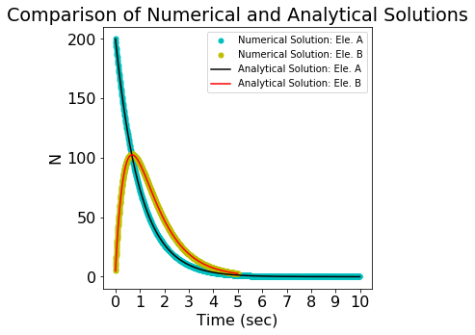

Figure 5: Here is the case in which $τ_{A}<τ_{B}$. This comparison between numerical and analytical solutions for each element also show no discrepancy, suggesting that the Euler method is an accurate way to approximate the solutions to the ODEs presented in equations (1) and (2).

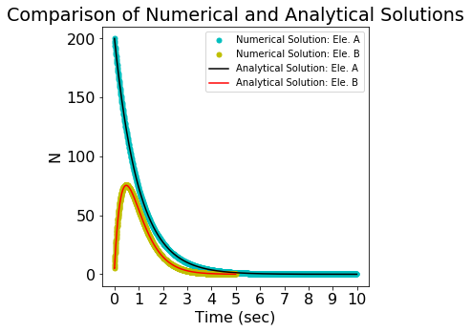

Figure 6: Here is the case in which $τ_{A}=τ_{B}$. This comparison between numerical and analytical solutions for each element again show no discrepancy, suggesting that the Euler method is an accurate way to approximate the solutions to the ODEs of this decay problem.

The implications of Figures 4, 5, and 6 are that for this coupled element radioactive decay problem, the Euler method makes for a good approximation of the exact solutions which can easily be found analytically.

*3.3* **Effects of Changing the Timestep**

One more aspect of this problem to note is the significance of the timestep, or time interval, *dt*. Changing the value of *dt* can have serious impacts on the efficiency of the numerical code and the accuracy of the resulting plots. This is because the Euler algorithms shown in equations (8) and (11) explicitly depend on the value of *dt*. The optimal timestep value rested somewhere around

$dt=0.01$. This *dt* value produced the figures presented above. However, if the value of *dt* is set to 1.0 instead of 0.01, the graph loses its accuracy as shown in Figure 7.

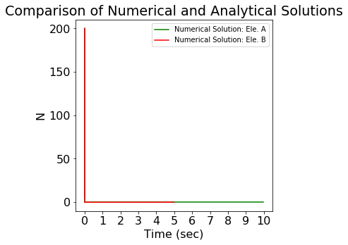

Figure 7: This plot, emphasizing the case where $τ_{A}=τ_{B}$, has been produced with dt=1.0 rather than dt=0.01. With such a high time interval, less points are being plotted which reduces the accuracy.

Now consider the case when $dt=0.00001$. This time interval is far too small for this problem. In this case, the efficiency of the code running the numerical simulation decreases causing the code to take longer to run and still produce meaningless results.

Therefore, finding a timestep interval that matches up with the situation in question is essential to retrieving accurate and meaningful numerical results. For decay problems, optimal *dt* values lie around the $dt=0.01$ range.

1. **Conclusion**

The radioactive decay problem is a great example of comparing numerical and exact solutions which can be computed analytically. In the specific case where element A decays into element B following the ODEs provided in equations (1) and (2), it can be seen that the values of the time constants $τ_{A}$ and $τ_{B}$ have a direct effect on the nature of each solution. When $τ_{A}>τ_{B}$ the value of the peak of $N_{B}\left(t\right)$ is less than that of the other cases. $τ_{A}<τ_{B}$ saw the case where element B had the highest number of nuclei. The case where $τ_{A}=τ_{B}$ showed that at this point, the rate of decay for both elements was almost identical.

The time interval *dt* value also played a vital role in determining the usefulness of the graph, with too big or too small of a time interval, almost no useful information could be obtained. Searching for a viable *dt* value is critical to obtaining a meaningful result to this situation.

When comparing the numerical results to the analytical solutions, there was almost no discrepancy. This suggests that the Euler method is an excellent approximation to find solutions for this type of decay problem. Numerical calculations and simulations are only becoming more vital as humanity pushes into the age of large data. Determining the accuracy and validity of certain of numerical approximations that can be tested against exact solutions is one very important way to test the validity of such approximations.